**Project 3 :- Create and Connect to a MySQL Database with Amazon RDS.**

**Summary:** Setting up a MySQL database with Amazon RDS provides a scalable, reliable, and cost-effective solution for hosting relational databases in the cloud.

**Diagram:**

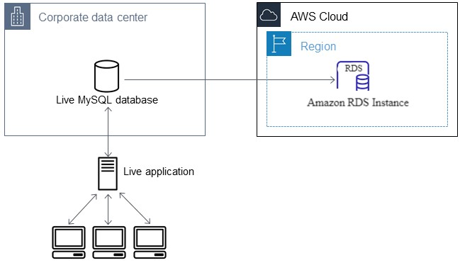

**Execution Steps:**

Here are simplified steps to create and connect to a MySQL database with Amazon RDS>

1. *Navigate to Amazon RDS*: Go to the Amazon RDS service in the AWS Management Console.

2. *Create a DB Instance*: Click on "Create database", choose MySQL as the engine, and follow the wizard to set up your DB instance. Specify your preferred settings, including username, password, DB instance size, etc.

3. *Configure Security Group*: During setup, configure the security group to allow inbound traffic on port 3306 (MySQL default) from your application servers or IP addresses.

4. *Launch the DB Instance*: Review your settings and launch the DB instance. Wait for it to be provisioned.

5. *Note Down Endpoint*: Once the DB instance is available, note down its endpoint (hostname) and port number.

6. *Install MySQL Client*: Install MySQL client tools on your local machine or server where your application will run.

7. *Connect to the Database*: Use the MySQL client to connect to your RDS instance using the endpoint, port, username, and password you configured.

8. *Create Schema and Tables*: Once connected, create your database schema, tables, and populate data as needed using SQL commands.

9. *Integrate Database into Project*: Update your project's configuration file with the database connection details (endpoint, port, username, password).

10. *Test Connection*: Ensure your project can connect to the MySQL database hosted on Amazon RDS. Test by running your application and verifying it can read from and write to the database as expected.